Part 1 – General

Please do not remove any parts of the PIA. Where a section does not apply, enter “Not Applicable.”
Answer the following questions. Read the red descriptive text and replace it with your own.
Name of District: | School District No. 92 (Nisga’a)
PIA Drafter: | <Name, Title of School District Contact>
Email: | <Email of School District Contact> | Phone: |  | <Number for SD Contact>
Program Manager: | <Name, Title of initiative contact, if different from PIA Drafter>
Email: | < Alternate to the above> | Phone: | <Alternate to the above>

- Describe the Initiative.

This section should provide a general description of the initiative and the context in which it functions. This could include the purpose of the initiative, its benefits, the larger process (if any) that it is part of, how it functions, the parties involved, etc. For example, the school district may want to overhaul its student engagement processes to better align with emerging self-service trends, or a program is moving forward because it is a priority project to modernize the school district’s operational system in supporting purchasing supplies in a timely manner for their schools.

- What is the scope of this PIA?
This section should explain, exactly what part or phase of the initiative the PIA covers and, where necessary for clarity, what it does not cover. For example, if a school district is overhauling its citizen engagement process to better align with emerging self-service trends and is launching new website features, this PIA may only be about the school district’s new blog. This blog would then be the “scope” of the PIA. This section may also describe what phase of the initiative this PIA covers.

- Are there any related Privacy Impact Assessments?
Identify, where applicable, PIAs for other parts of the initiative or any other PIAs that were previously completed for this initiative. To follow from the above example, this PIA has already been completed for the school district’s website and was published for public to viewing at the beginning of the school year.
- What are the elements of Information or data in this initiative?
List the elements of information or data involved in this initiative. This could include student’s name, age, address, work/home email, work/home phone number, educational history, employment history, work status, health information, financial information, photos, comments on a blog, social media, or information specific to your subject area, such as assessments, student results, or person(s) responsible for supervising the initiative.
If no personal information is involved, please submit Part 1: (Questions 1 -4), Part 6: Privacy Officer(s) Comments and Part 7: Program Area Signatures to your privacy office(r).
They will guide you through the completion of your PIA.

Part 2 – Protection of Personal Information
If personal information is involved in this initiative, continue to the next page to complete your PIA.

Answer questions (5 – 7) then, read the red descriptive text 7 – 10 and replace it with your own.

- Is the storage or access of your information outside Canada?
Provide a brief description of whether your information can be or will be accessed from outside Canada, for example, a service provider that is repairing the system, or if your information is being stored outside Canada, as in the “cloud”, which jurisdiction is the “cloud” located.
- Is this a data-linking Initiative?
In FIPPA, "data linking" and “data-linking initiative” are strictly defined. Answer the following questions to determine whether your initiative qualifies as a “data-linking initiative” under the Act. If you answer “yes” to all 3 questions, your initiative may be a data linking initiative and you must comply with specific requirements under the Act related to data-linking initiatives.
- Personal information from one database is linked or combined with personal information from another database; | yes/no
- The purpose for the linkage is different from those for which the personal information in each database was originally obtained or compiled; | yes/no
- The data linking is occurring between either (1) two or more public bodies or (2) one or more public bodies and one or more agencies. | yes/no
If you have answered “yes” to all three questions, please contact your privacy office(r) to discuss the requirements of a data-linking initiative.

DISTRICT NOTE: Data linking means the linking or combining of personal information in one database with personal information in one or more other databases if the purpose of the linking or combining is different from:
(a) the purpose for which the information in each database was originally obtained or compiled, and
(b) every purpose that is consistent with each purpose referred to in paragraph (a). I.e. in the case of an online product where the purpose of the linking is not different than the reason for which the information was originally obtained or compiled.
- Is this initiative a Common or Integrated Program/Activity?

In FIPPA, “common or integrated program or activity” is strictly defined. Answer the following questions to determine whether your initiative qualifies as “a common or integrated program or activity” under the Act. If you answer “yes” to all 3 of these questions, you must comply with requirements under the Act for common or integrated programs and activities.
- This initiative involves a program or activity that provides a service (or services); | yes/no
- Those services are provided through:  (a) a school district and at least one other public body or agency working collaboratively to provide that service; or  (b) one school district working on behalf of one or more other public bodies or agencies; | yes/no
- The common or integrated program/activity is confirmed by written documentation that meets the requirements set out in the FOIPP regulation. | yes/no
Please check this box if this program involves a common or integrated program or activity based on your answers to the three questions above.

If it has been determined by your designated privacy officer that your initiative does involves a “data-linking initiative” or a “common or integrated program or activity”, advanced notification and consultation on this PIA must take place with the Office of the Information and Privacy Commissioner (OIPC). Your school district’s privacy office(r) will determine how to proceed with this notification and consultation.

For future reference, School Districts are required to notify the OIPC of a” data-linking initiative” or a “common or integrated program or activity” in the early stages of developing the initiative, program or activity. Contact your school district’s privacy office(r) to determine how to proceed with this notification.

- Complete a Personal Information Flow Diagram and/or Personal Information Flow Table
If applicable, provide a diagram and/or table that shows how your initiative will collect, use, and/or disclose personal information (see examples below). Your diagram and/or table must also include the authorities for the collection, use, and disclosure of personal information (see Appendix B in this document), as laid out in FIPPA. It should also outline the flows of personal information wherever it is transmitted or exchanged.
Both a flow diagram and a table must be included if the PIA is related to a “common or integrated program or activity or a data-linking” initiative.
If the person initiating this PIA is unsure of the collection, use, and disclosure authorities of FIPPA found in Appendices A - C. and does not know what the relevant authorities are, please contact your district/school privacy office(r).
Depending on the complexity of your initiative, you may choose to provide one general diagram for the initiative, and more specific diagrams for the components. If multiple organizations will collect, use, or disclose personal information, the diagram should identify how each organization is involved in the initiative.
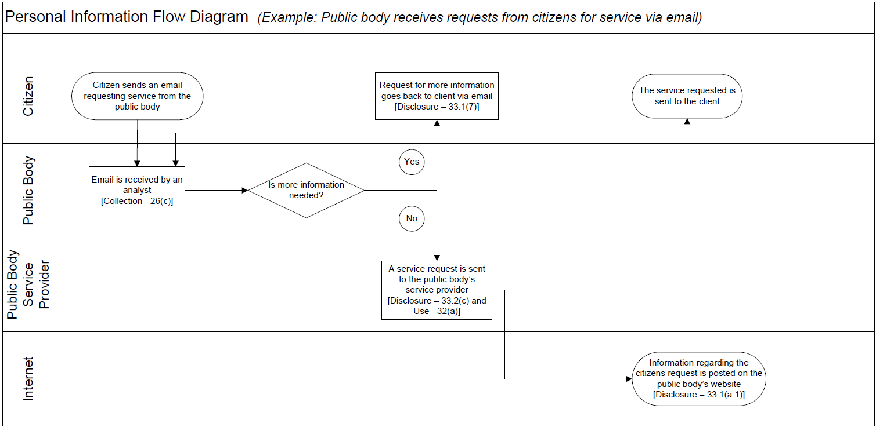
Example:

Note: The examples below can be removed, and additional text lines can be added as needed.
Personal Information Flow Table
 | Description/Purpose | Type | FIPPA Authority
1. | E.g. Email received from client requesting service | Collection | 26(c)
2. | E.g. Email client back requesting more information | Disclosure | 33.1(7)
3. | E.g. Service request transferred to service provider contracted by school district | Disclosure & Use | 33.2(c) and 32(a)

- Complete the Risk Mitigation Table below.
Please identify any privacy risks associated with the initiative and the mitigation strategies that will be implemented. Please provide details of all such strategies. Also, identify the likelihood (low, medium, or high) of this risk happening and the degree of impact it would have on individuals if it occurred.
Note: The examples below can be removed, and additional text lines can be added as needed.
Risk Mitigation Table
 | Risk | Mitigation Strategy | Likelihood | Impact
1. | E.g. Employees could access personal information and use or disclose it for personal purposes | Oath of Employment; contractual terms, etc. | Low | High
2. | E.g. Request may not actually be from client (i.e. their email address may be compromised) | Implementation of identification verification procedures | Low | High
3. | E.g. Client’s personal information is compromised when transferred to the service provider | Transmission is encrypted and over a secure line | Low | High
4. | E.g. Inherent risks in sending personal information to a client via email | Policy developed to inform clients of risk and ask if they would like the information via a different medium, such as through the mail | Medium | Medium

- Provide a Collection Notice
If your initiative is collecting personal information directly from individuals, you must ensure that all persons involved are told the following:
- The purpose for which the information is being collected
- The legal authority for collecting it, and
- The title, business address and business telephone number of an officer or employee who can answer questions about the collection.
Please include your proposed wording for a collection notice and where it will be located for individuals to read before collection takes place. You can also attach a screen shot or a copy of your form where the collection notice would be located. For further help with collection notices please see the “Collection Notice Tip Sheet” located on the BC Government CIO’s website.
DISTRICT NOTE: For further help with collection notices please see Tip Sheet for Consent & Disclosure located on the ERAC website.

Part 3 – Security of Personal Information
If this PIA involves an information system, or if it is otherwise deemed necessary to do so, please consult with your school district’s privacy office(r) and/or security personnel when filling out this section. They will also be able to tell you whether you will need to complete a separate security assessment for this initiative.

- Please describe the physical security measures related to the initiative (if applicable).
For example, the use of locked cabinets, securely stored laptops, or key card access to the building.

- Please describe the technical security measures related to the initiative (if applicable).
For example, the use of firewalls, document encryption, or user access profiles assigned on a need-to-know basis.
- Does your district department rely on any security policies and procedures?
Describe your specific technology user policies and procedures. Also, provide contact details for the designated person who could answer further questions regarding these policies and procedures.
- Please describe any access controls and/or ways in which you will limit or restrict unauthorized changes (such as additions or deletions) to personal information.
For example, district authorized role-based access.
- Please describe how you track who has access to the personal information.
For example, the use of audit trails or physical sign-in and sign-out of files.

Part 4 – Accuracy/Correction/Retention of Personal Information

- How is an individual’s information updated or corrected?

If personal information is not updated or corrected (for physical, procedural or other reasons) please explain how it will be annotated? If personal information will be disclosed to others, how will the school/district notify them of the update, correction or annotation?
For example, users have access to update their own information or enrolling teacher(s) will have the ability to modify student records including notes being made on a specific student record.
- Does your initiative use personal information to make decisions that directly affect an individual(s)? If yes, please explain.

For example, the performance on tests and quizzes, grades and other annotated notesare used for assessment.

- If you answered “yes” to question 17, please explain the efforts that will be made to ensure that the personal information is accurate and complete.
For example, check to see that the information from the application was obtained and recorded by the enrolling teacher and that there is matching duplicate secure records in the district approved student information system.
DISTRICT NOTE: For additional information on the Privacy Management and Accountability Policy (May 2016) see: https://bcerac.ca/wp-content/uploads/2018/05/Privacy-Accountability-2016.pdf

- If you answered “yes” to question 17, do you have a records retention and/or disposition schedule that will ensure that personal information is kept for at least one year after it is used in making decisions directly affecting an individual?
If you do not yet have a schedule, please document how these records will be kept until the schedule is in place. Please describe retention schedules that apply where retention exceeds the one-year requirement of FIPPA. For further information on “Records Retention” see the BC Government's, Services, Policies and Procedures, Section 31 - Retention of personal information or contact your school district’s privacy office(r) and/or records office(r) if you require assistance.

Part 5 – Further Information
- Does the initiative involve systematic disclosures of personal information? If yes, please explain.
For example: your department has a regular exchange of personal information (both collection and disclosure) with the federal government to provide services to your clients.
Please check this box if the related Information Sharing Agreement (ISA) is attached. If you require assistance completing an ISA, please contact your privacy office(r).

- Does the program involve access to personally identifiable information for research or statistical purposes? If yes, please explain.
For example: your school district will be disclosing information to PhD students so that they can conduct research.
Please check this box if the related Research Agreement (RA) is attached. If you require assistance completing an RA please contact your privacy office(r).

- Will a personal information bank (PIB) result from this initiative? If yes, please list the legislatively required descriptors listed in section 69 (6) of FIPPA. Under this same section, this information is required to be published in a public directory.
A personal information bank means a collection of personal information that is organized or retrievable by the name of an individual or by an identifying number, symbol, or other assigned to an individual.
< If you have any questions regarding the above section, please contact your school district’s privacy office(r) or call the OCIO’s Privacy and Access Helpline at 250 356-1851.>
Please ensure Parts 6 and 7 are attached to your submitted PIA.

Part 6 – Privacy Office(r) Comments
This PIA is based on a review of the material provided to the Privacy Office(r) as of the date below. If, in future, any substantive changes are made to the scope of this PIA, the school district will have to complete a PIA Update and submit it to Privacy Office(r). See attached document.

A note to the reader: We cannot say with any degree of certainty what the unintended consequences could potentially arise out of the use of the user’s data if it were to be shared with others. If users were to transfer their data on a personal email account, even though they have been directed not to do so, the school district will not know for certain, whether their data is being ‘touched’ by an agency outside of the country. In other words, we don’t have a high degree of certainty that the data that is being collected and stored on our secure district server/vendor’s server is being potentially indirectly used, other than what has been described in the scope of this PIA.

Also, unless the Agreement otherwise specifies, or if the district otherwise directs in writing, the vendor must not disclose any personal information outside of Canada.

Privacy Officer/Privacy Office Representative |  | Signature |  | Date

Part 7 – Program Area Signatures

Program/Department Manager |  | Signature |  | Date
Contact Responsible for Systems Maintenance and/or Security (Signature not required unless they have been involved in this PIA.) |  | Signature |  | Date
Head of School district, or designate |  | Signature |  | Date

A final copy of this PIA (with all signatures) must be kept on record.

If you have any questions, please contact your school district’s privacy office(s) or call the OCIO’s Privacy and Access Helpline at 250 356 1851.

